Opening Up Buildings for Black Businesses: the positive impact of physical spaces
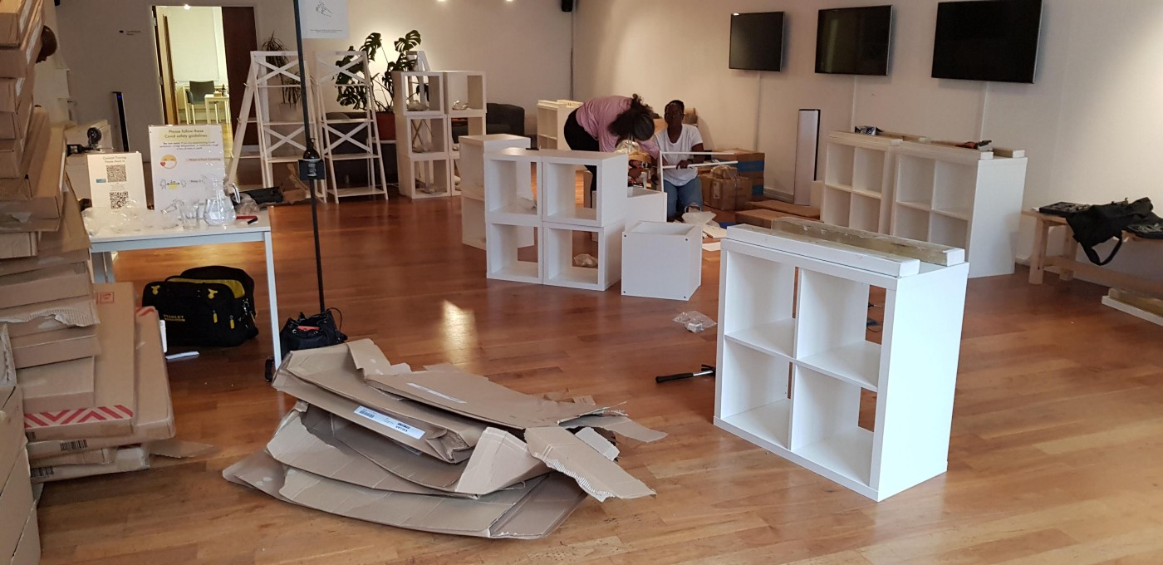
Building shelves for Afrori Books physical shop in Lighthouse reception area. Photo: Alli Beddoes.

“If a small charity can do this for a Black Business in Brighton, imagine the possibilities of what else could happen?!”

— we heard this comment, during the launch of Afrori Books physical shop in the Lighthouse building, on 23 October 2021. And it really resonated with us: what are the possibilities? What else can happen if more organisations consider opening up and sharing their space?

We understand that one Black-owned business that exists separately as an anomaly is not enough. In the same way that, in our building, Afrori Books needs time and space to bring in existing connections and cultivate new networks for its safe space to resonate with people — so do other businesses, projects and groups around Brighton that are led by people of the global majority. There is a need for more opened up physical spaces and unhurried long-term opportunities for such projects to connect, align and collaborate — this is where we will truly enjoy the change in the fabric of our city and for the better.

In this blog, we want to share some of the positive impacts our charity has felt since the shop’s opening, alongside some crucial things we’ve learned in the process. Here they are:

Positive Impact

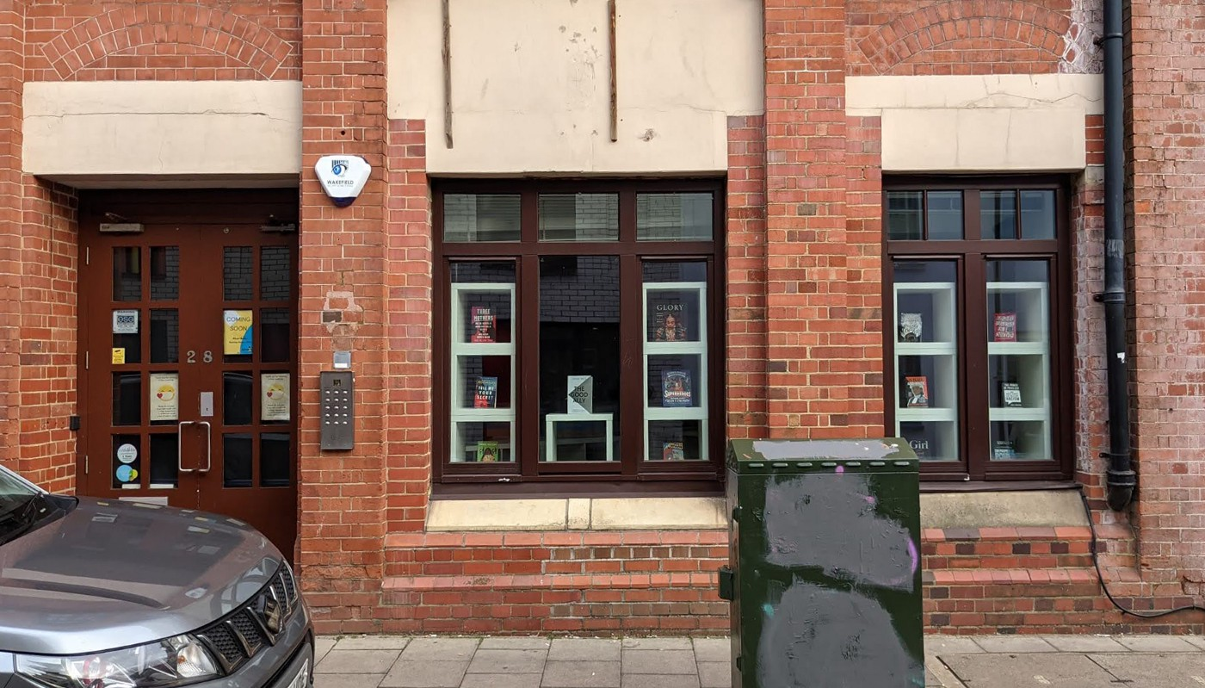
Afrori Books shop at Lighthouse, 28 Kensington Street, Brighton. Photo: Ysabel Bain.

- Having a bookshop in the building has activated our Reception Area (which was often closed to the general public) in a consistent and positive way.
The shop is open Tuesday-Saturday 10am-5.30pm, and due to our building’s location in the busy North Laine, it attracts a lot of visitors. We were not utilising the space to its fullest extent, and now it benefits a vital business.

- Our door is open for all during the shop’s working hours, and people in the city feel a deeper connection to our building.
One of our charity missions is to ensure our building is accessible to the broader public to support local creative practice and development beyond the programme that Lighthouse curates and produces. Having Afrori Books in our building supports that mission, and we are working to develop this further.

- Having a bookshop that platforms and celebrates Black authors in our building has created endless opportunities for productive conversations and interpersonal connections to aid the anti-racist movement.
Afrori Books is encountered daily by many users of our building: Lighthouse staff and board, our artists, the building tenants and venue hirers. We have noticed that this shift to the physical environment inspires new habits and modes of interaction with the space and with each other. It also provides users of the building and the team with an unprecedented access to varied literature by Black authors, generates conversations, and gives us an opportunity to embody our learnings.
What we’ve learnt
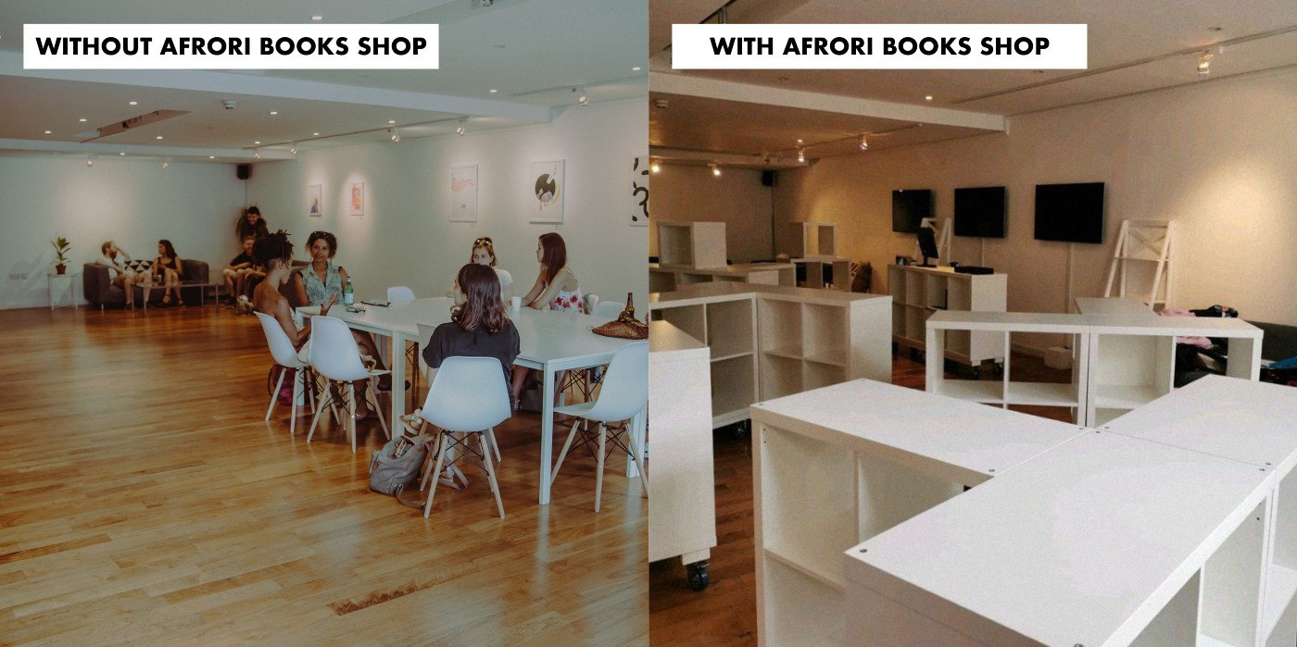
Before and After images of our Reception space. Photo 1: Stewart Gardiner. Photo 2: Ysabel Bain.
1. A flexible space is an asset but also a challenge and requires regular check-ins and adaptation.
For Afrori Books, we specifically customised units by fixing on wheels, to allow Carolynn the freedom to change the setup to suit the bookshop’s needs. In turn, this enables us to temporarily regain access to the entire space as we work to rebuild our venue hire offer. As with everything in this collaborative journey, we’ve learnt that regular communication, care, openness and flexibility are key.
2. Art charities are a necessity, not a luxury. However, there is much to learn about the possibilities and limitations of charities.
Due to massive cuts to various social services across the UK, arts charities are playing a crucial role in our society — tending to needs that have been left unattended, to the best of our abilities. Not all arts charities had an opportunity to adapt or survive, and we are lucky that our work continues to create an impact locally and internationally. That’s why we consider it our responsibility to respond to the needs of our communities, but we are also aware we can’t do it all on our own (nor it is our place).
3. Bookshops are more than books for sale. However, there is much to learn about the possibilities and limitations of retail.
Afrori bookshop is more than a space that sells books by Black authors. With multiple events and activities for people of all ages, it is quickly becoming a community hub. It is changing the cultural landscape of our city by being a physical, tangible sign of the effort to create a fairer society.
Afrori’s promotion of books continues to make an impact, they write: “In the past year, we have seen publishers having to do extra print runs because we have promoted a book and it has sold out. The work we do is important and it is making a difference.”
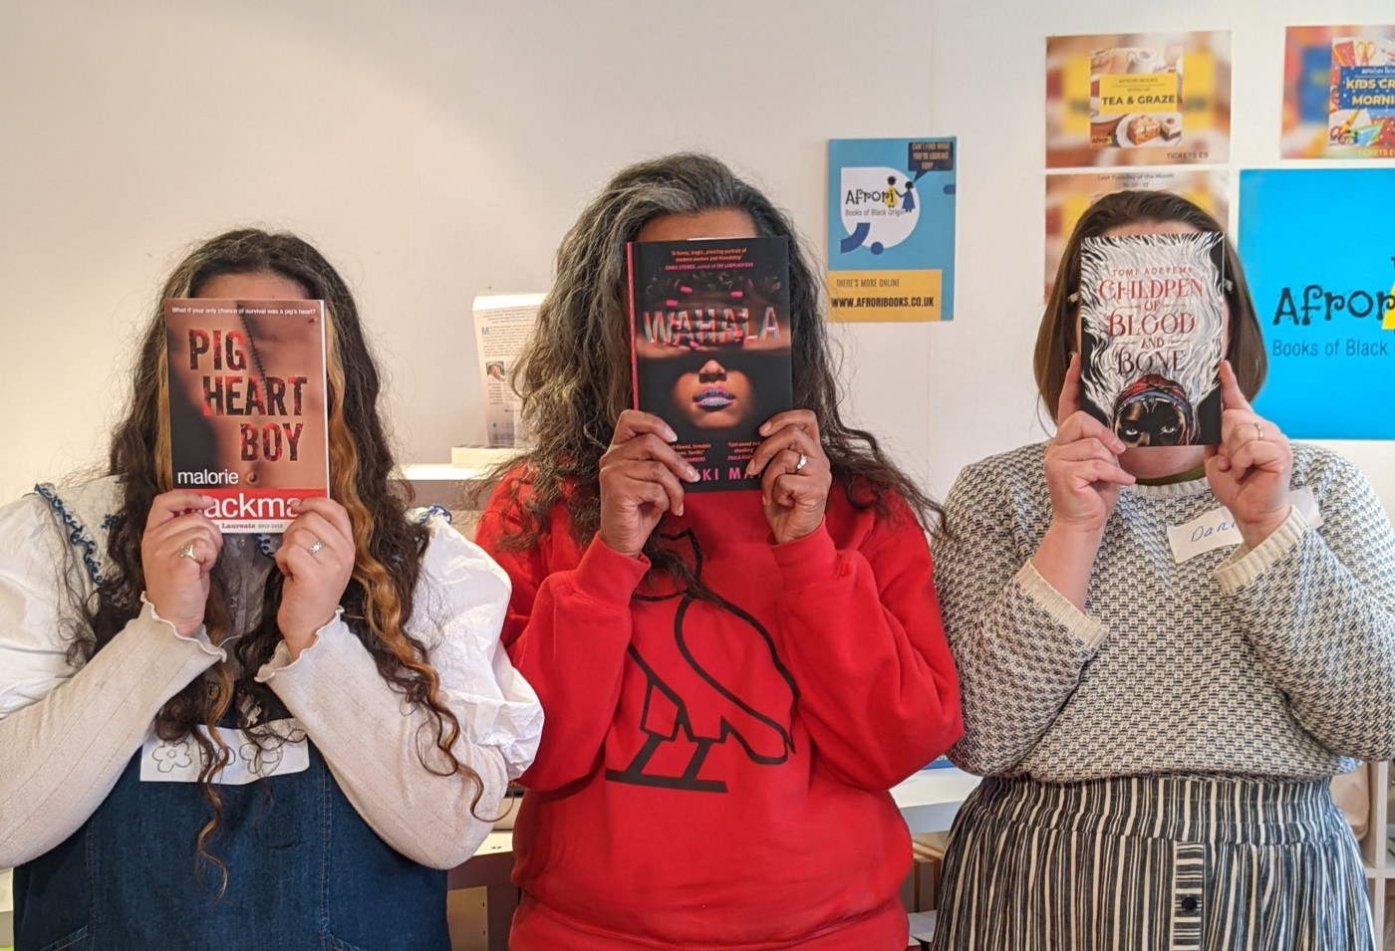
Founder Carolynn Bain (in the middle) with two Afrori Books event volunteers. Photo: Ysabel Bain.
4. Holding a safe space for people is a daily active practice and can always be improved.
The bookshop is becoming what Carolynn Bain hoped it would be — a cultural hub and a safe space for Black people to be themselves. The space invites Black people to forget about code-switching and not worry about microaggressions, as they sit among all kinds of books that centre the multitude of Black experiences. However, the upkeep of a safe space is a big commitment and a daily practice for everyone in the building.
5. The inequalities and need for change are apparent. Brighton is a city that can do more to support businesses and communities that face oppression.
“In Brighton, there are little to no spaces where Black people can gather to just be and still feel safe. By safe I don’t just mean free from physical violence (although that is of course important), I mean safe to be themselves.” — from Afrori Books Blog.
At Lighthouse, we are committed to dismantling systemic inequality, we recognise the need for spaces like ours to do more, to make real, permanent change in our organisation and the city we work in. We hope every move made towards change will influence other organisations to make changes that can hold different safe spaces in alternative ways.
6. You can build anything together. Brighton is a city of people who want to make great things happen and are ready to mobilise their voices, resources, connections and creativity.
We have been positively overwhelmed by support and contributions that helped Afrori Books become a physical bookshop. Similarly, The Feminist Bookshop opened its physical space in Brighton in November 2019, following a crowdfunder campaign. The Queery, a queer community space with a library and a radical bookshop, have been running their crowdfunder since July 2021, now with an extended target to cover extra costs.
It shows the present-day importance of independent cultural hubs, and we cannot wait to see what dreams Brightonians will realise next.
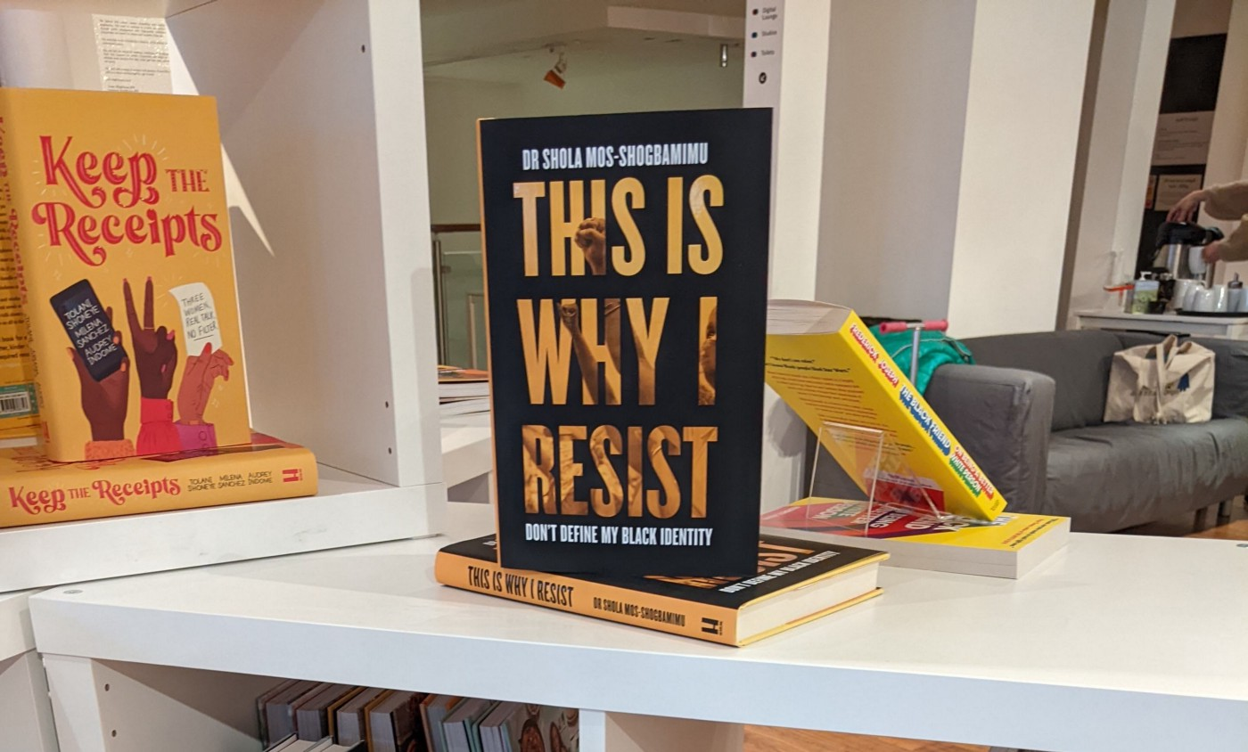
Bookshelf with “This Is Why I Resist” book on display. Photo: Ysabel Bain.
We are so proud of where we’ve got to, and delighted Carolynn took the plunge with us. Thanks to her, Oliviyah, Ysabel and the rest of the Afrori Books staff for continuing this journey with us.

We encourage more businesses, organisations and individuals with access to multi-use physical spaces to consider the impact of sharing that space. We are still learning, but if anybody wants to find out more about our journey and its process — please do get in touch. We hope more learning and progress can come through sharing our experiences.

We recognise that all partnerships in physical spaces require openness through conversations, adaptations, reflections and revision to ensure continued support, and nurture the importance of how we hold space, and the value they bring to the city. Brighton is a special city, when we work together anything is possible.

How we got here: about Lighthouse & Afrori Books collaboration
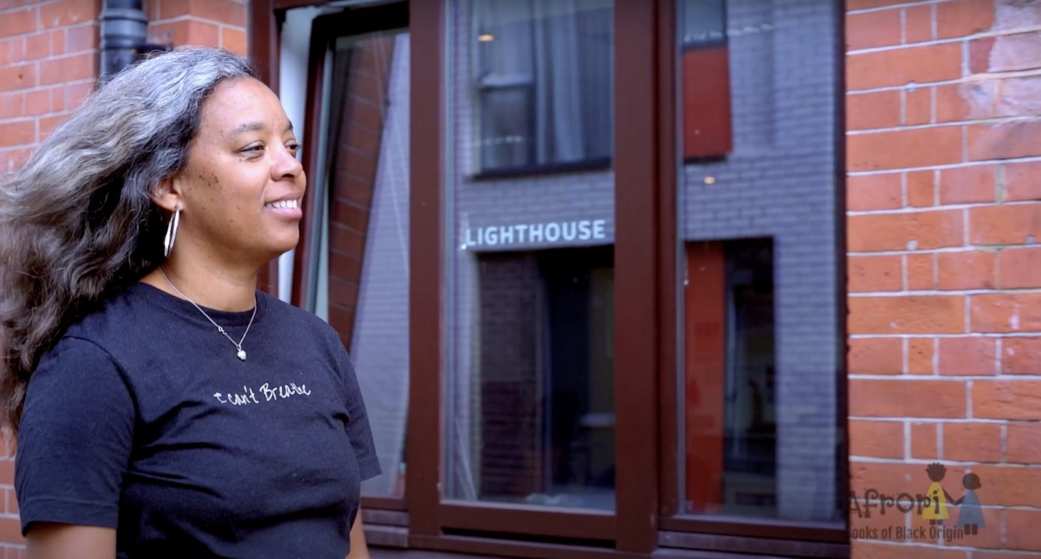
Still image showing Carolynn Bain by Lighthouse building from crowdfunder video.
In August 2020, Lighthouse team posted our Anti-Racism plan. One of the actions in the plan was to offer the large Reception Area in our building on 28 Kensington Street to a Black-owned business. We particularly hoped that it could be a Black-owned bookshop, as there had not yet been such an establishment in Brighton or the whole of Sussex.
Afrori Books has existed as an online shop since 2020. Following the murder of George Floyd, the founder Carolynn Bain decided to set up a website where people could easily locate books by Black authors and where black authors would have a platform that they did not seem to get in other bookshops.
After being approached by Lighthouse with an offer of space, Afrori Books launched a crowdfunding campaign on 31 August 2021 to bring the idea to life. Afrori Books reached half of the target sum on 6 September 2021, and on 8 October, the crowdfunder closed with an exceeded target sum of £12,460. On 26 October, the shop opened its doors to the public and only one month later, Afrori won the national FutureBook Best Start-Up Award for highly commended business.

28 February 2022

