Detailed Audience Experience Guide

Paso – Exhibition at Fabrica
21-30 January 2022
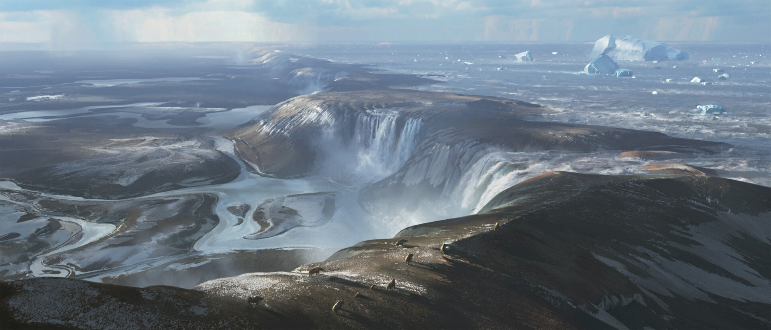
Fabrica, 40 Duke St, Brighton

Paso - The Story

Paso is a spatial sound experience serving as a memorial to an extinct migration route. It remembers the chalk land bridge that once connected Britain to Europe and the animal migrants (including 3 species of early humans) that crossed it until its collapse due to climate change 450,000 years ago.

Throughout its lifetime, the land bridge was continually changing. Glacial and interglacial periods saw temperatures change and sea levels rise and fall, transforming its landscape and dictating the types of animals that were able to occupy it. These ranged from rhinoceros and lions to reindeer and mammoths, and included three species of early humans.

Paso invites you to imagine what this human-free, completely animal landscape was like. In de-prioritising vision (often understood as Homo sapiens’ primary sense) to focus on close-listening and close-touch, the work invites more awareness of our bodies and the way that they are present and interactive within an environment.

Paso is a passing place, celebrating freedom of movement, and offering space to consider the topic of migration from a less human-centred perspective. It serves as a reminder that many migration routes we take for granted are at risk of becoming extinct in the future due to the effects of human decision-making and climate change.

Paso - Experience, Access and Health & Safety Information

The exhibition will have measures put in place in alignment with the latest government Covid guidelines. Our staff will be continuing to wear face coverings and observe social distancing. We would be very grateful if you could support us and other visitors by also wearing a face covering if you are able to, using the hand sanitiser provided, and socially distancing whilst in our building. All equipment and objects that are touched by guests or members of staff will be sanitised regularly.

We will provide Track and Trace, and the NHS Track and Trace QR code will be located at our front desk

The artists invite you to move over the floor sculpture barefoot. If you prefer to use shoe coverings for your feet or shoes, you can find these by your chair. The soil contains coconut fibres. If you have a coconut allergy we recommend you use the cover for your feet.

The gallery entrance and exit both have ramps and are wheelchair accessible. Although the sculpture surface is uneven, it can also be experienced in a wheelchair.

The work is designed to be inclusive for blind, visually-impaired and sighted visitors. If you have a visual impairment, please let the staff know as you register your arrival. You are welcome to bring your cane or guide dog in the space with you. Alternatively we can offer a covid-safe guide-rope in order for our invigilator to help you safely explore the work without physical contact, if that is your preference.

Fully accessible toilets and baby changing facilities are available and accessible from within the main space.

Paso - Experience Guide

The Fabrica building is a former church. Fabrica operates a one-way system through the space. The entrance is via the door on Ship Street and the exit is via the door on Duke Street. Both doors have ramps and are wheelchair accessible.

You will be welcomed by a member of the Front House team in a small reception space where you will be checked in.
A member of staff will then lead you into the exhibition space, which is in the main long room in the church. You will be guided to the start of the exhibition here.

In front of you, there will be a 3D model that represents the landbridge. You are invited to touch the model if you would like to. You will be asked to sanitise your hands before doing so and the model will be sanitised regularly.

On one side you will feel the UK. If you follow the coast you will then find Dover and Brighton. On the other side you have Calais in France and you can follow the landbridge that used to connect them. On the north side of the landbridge there was a huge lake containing the waters of the Thames and Rhine. The land bridge became a migration highway transporting the first land animals into Britain.

You will then be guided to the installation just beyond the model, still in the nave of the church. The space is dark and lit mostly at ground level. In the middle of the room, on the floor, there is a large rectangular soil surface of around 5x8 meters. 4 chairs sit along the side of the soil sculpture. You’ll be invited to sit on a chair where you can take off your shoes and leave your belongings. When you are ready, you will be invited to put on a pair of Bluetooth headphones. Chairs and headphones will be sanitised between each use.

We will then take you to the edge of the floor sculpture, which you will be invited to move over.

As you move through the designated floor space, the sounds you hear through the headphones evoke the human-free landscape of the land bridge, and will change depending on your position. There are no sudden loud noises, and all the sounds are contained within the soil floor area.

The soundscape changes depending on your position in the space. We recommend that you move around and explore every corner, it will become clear how it works as you do. The installation covers the area where the soil is, and there are no objects or barriers in this area. There will be up to 3 other people in this area with you and we ask that you remain within it. You will feel underfoot where the sculpture area ends, and the stone floor of the church floor begins.

The floor is heated to evoke the ‘seasonal’ nature of ice ages and changing sea levels that surrounded the bridge throughout its lifetime.

The soil material doesn’t leave residue on the feet, it is dry so it wipes easily with the tissues we provide.

When you have finished exploring the composition, please signal to us, and we will come back over to you. We invite you to spend a maximum of 15 minutes in the space. If your time is up we will signal to you by calling your name.

If you have any questions or problems with the technology at any time you can signal for assistance.

At this point, you will be invited back to your chair, and then towards the exit.

Should the emergency alarm sound you will be directed to your nearest exit by a member of staff and requested to make your way to our meeting point outside of Nandos on Duke Street.

Paso - About the artists

Alberto and William are a Spanish sound artist and British artist who began collaborating with one another over 7 years ago. They share an interest in creating immersive experiences that encourage a heightened awareness of the audience’s own body/senses and that serve as environments within which to explore the body and new ways of thinking; in this particular work non-human (less human-centred approaches) to migration/migrants/migration routes.

Paso follows on from a Re-Imagine Europe residency at Lighthouse during November 2019 where they were interested in the use of VR technology to make a predominantly non-visual experience where sound and tactile elements were the core sensory elements. Also how this technology can redefine our understanding of sound/music composition, where sound is arranged in space rather than time, and the movement of the audience’s own body decides the manner in which the composition unfolds.

Alberto Ruiz Soler is a sound artist and composer researching how people perceive sound and categorise their sonic environment. He constructs listening experiences through contemporary dance, installations and generative art. He is part of internationally touring works with artists like Igor+Moreno, Lola Maury, Eva Recacha, Hannah Ringham & Glen Neath, Hetain Patel.

www.albertoruizsoler.com
Instagram: @albertoruizsoler

William Fairbrother is a non-anthropocentric artist and researcher based in London. His works usually involve collaborations with other researchers / creative practitioners and are focussed towards the use of art as a tool to enable less human-centred points of view. He is currently concentrated on developing physical experiences that prioritise the subordinate senses over vision which dominates the art sector and media-centric world we live in today.

www.williamfairbrother.co.uk
Instagram: @williamfairbrother

Credits

The artists would like to thank Professor Sanjeev Gupta from Imperial College London, leading expert on the landbridge, for his collaboration.Special thanks also go to:

Antoine Hacheme
Jon Hawkens
Carlos Jiménez
Ed Kashinsky
Lola Maury
Maria Oshodi
Seth Rook Williams
Dr Cecilia Wee

Paso is produced by Lighthouse in partnership with Fabrica supported by Arts Council England and Re-Imagine Europe. Lighthouse is part of Re-Imagine Europe, which is co-funded by the Creative Europe programme of the European Union. Re-Imagine Europe is initiated by Sonic Acts (NL) and coordinated by Paradiso (NL) in collaboration with Elevate Festival (AT), Lighthouse (UK), Ina GRM (FR), Landmark / Bergen Kunsthall (NO), A4 (SK), Disruption Network Lab (DE), Ràdio Web MACBA (ES), Urban Paradoxes (NL) and Kontejner (HR). The exhibition has been realised with the support of Arts Council England and Fabrica.

